Name: __________________________________________________________________________________
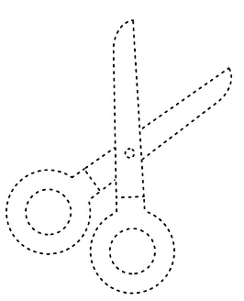
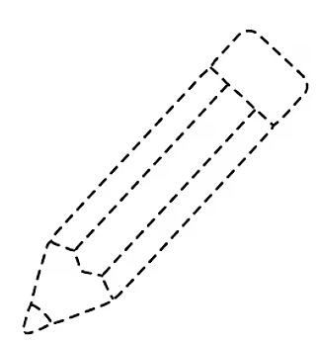
WHAT IS THIS?
THIS IS A PENCIL THIS IS A SCISSORS

